**EduHub: Collaborative Learning Platform**

**Developed By: Yash Rebbawar**



**Introduction:**

**Project Name:** Edu_Hub_Project

Edu_Hub_Project is an innovative online educational platform designed to connect students with learning resources and services. This web-based application aims to streamline the educational process by providing a centralized hub for students to access course materials, interact with educators, and manage their academic journey.

**User Authentication:**

1. Student Login
2. Educator Login

**Architecture:**

1. **Framework: ASP.NET Core**

The project is built using ASP.NET Core, which is a cross-platform, high-performance framework for building modern, cloud-based, Internet-connected applications.

1. **Pattern: MVC (Model-View-Controller)**

* While this is a Razor Page, the overall architecture likely follows the MVC pattern, which is common in ASP.NET Core applications.
* Model: The @model directive at the top references a Login model, suggesting a separation of data concerns.
* View: This Razor Page acts as the View, presenting the UI to the user.
* Controller: Although not shown, there's likely a controller handling the form submission (referenced by the asp-action="SLogin" attribute and asp-action="ELogin").

1. **Front-end:**

* Razor Pages: The .cshtml file combines C# with HTML for server-side rendering.
* CSS: A combination of Bootstrap and custom styles for responsive design.

1. **Data Binding:**

The form uses model binding with asp-for attributes, connecting the UI elements directly to the model properties.

1. **Authentication:**

* Custom authentication system (as opposed to using Identity, which is not visible in this snippet).
* The login form submits to a SLogin and ELogin action, suggesting a custom authentication handler.

1. **Dependency Injection:**

While not explicitly shown, ASP.NET Core's built-in dependency injection is likely used throughout the application.

1. **Configuration:**

The application likely uses the standard ASP.NET Core configuration system (appsettings.json, environment variables, etc.)

1. **Routing:**

ASP.NET Core's routing system is used to map requests.

1. **Error Handling:**

Basic form validation errors are handled and displayed to the user.

1. **Security:**

HTTPS is likely enforced (standard in ASP.NET Core)

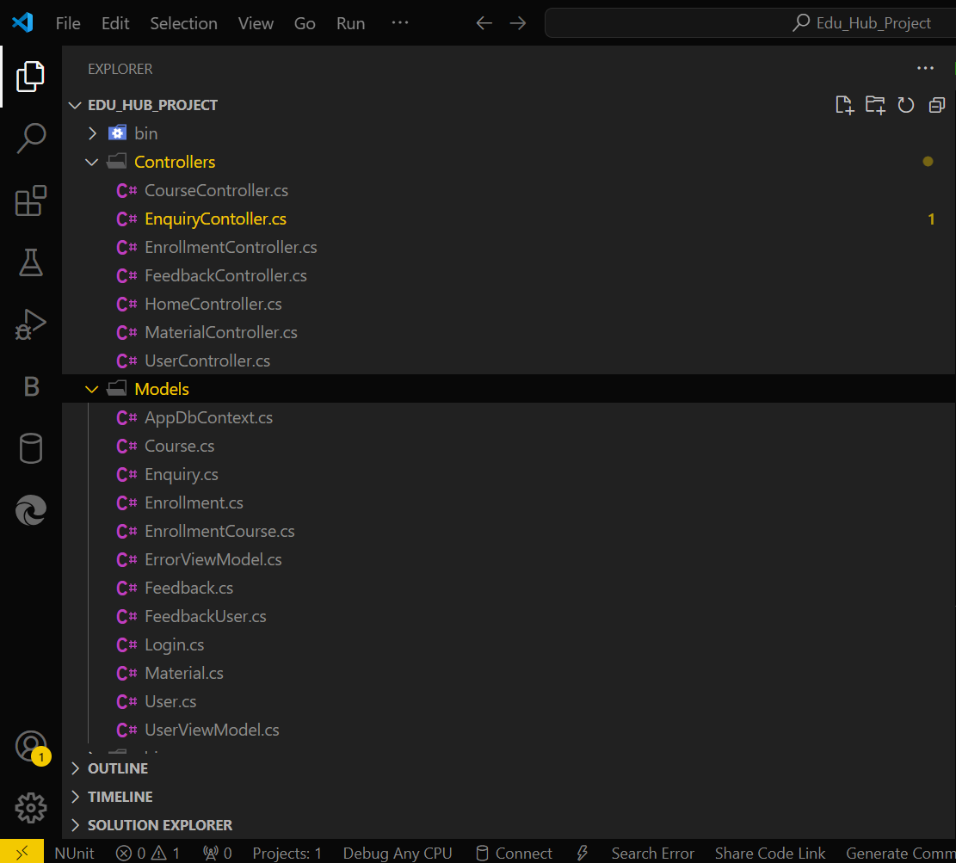**Folder Structure**

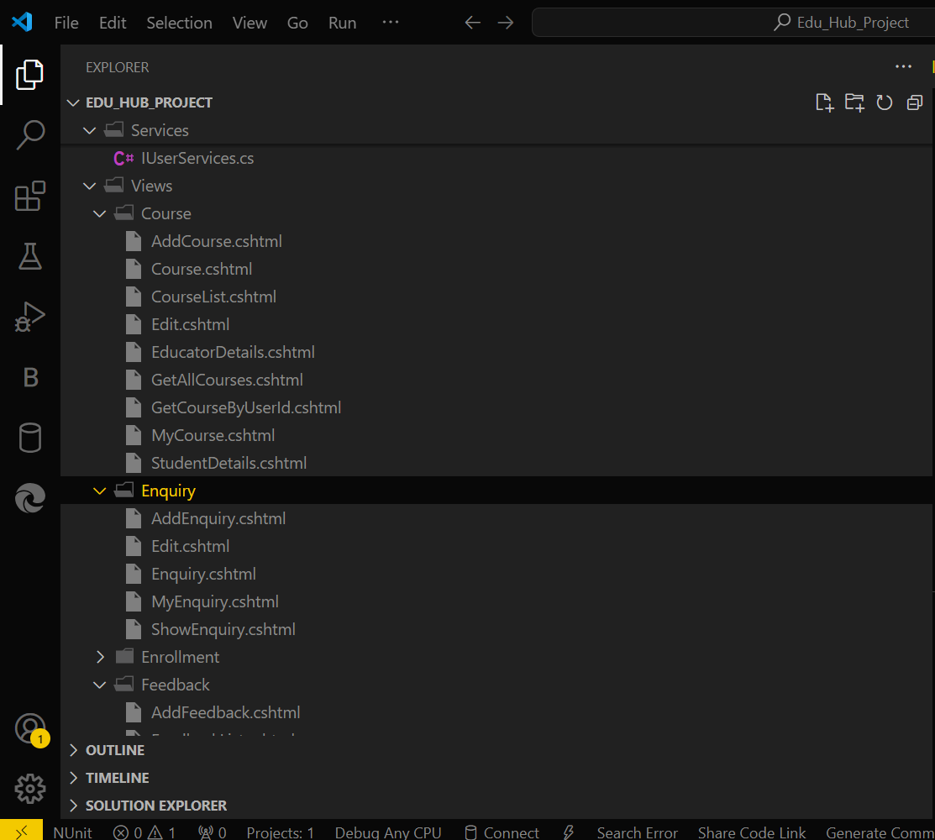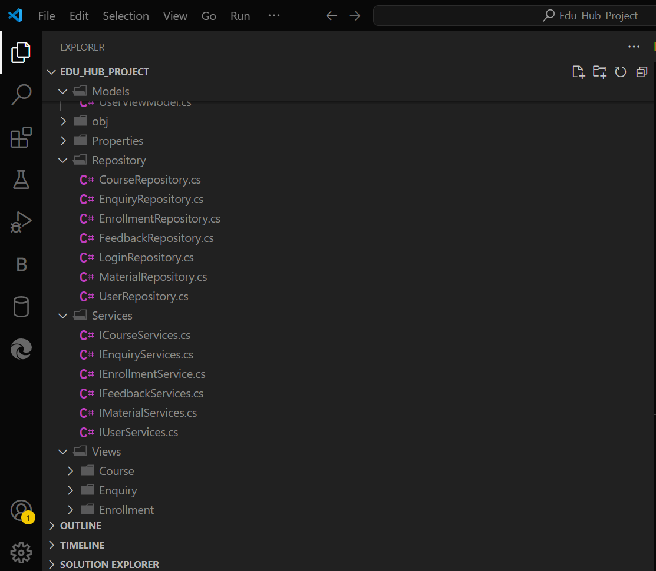

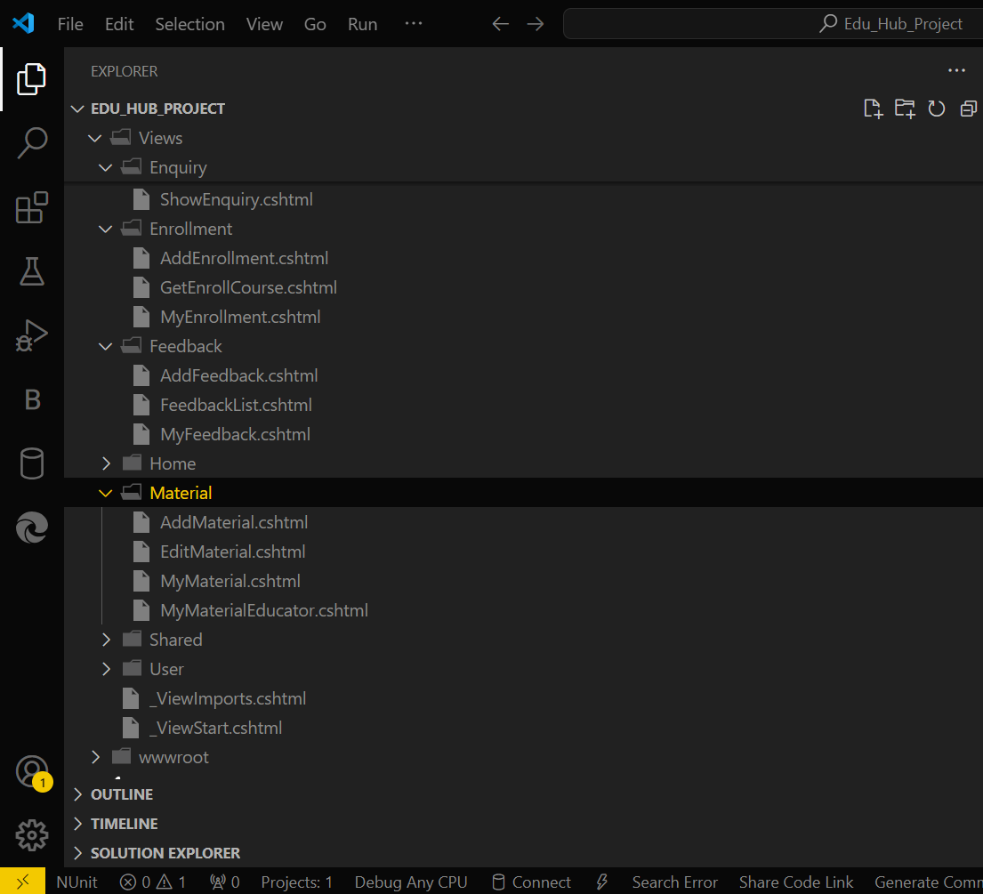

**Educator Actions:**

**Flow Diagram:**



**Course Management Features for Educators**

1. **Create Course**

* **Functionality:** Educators can create new courses.
* **Required Information:**
* Title
* Description
* Start Date
* End Date
* **Role Assignment:** Educators are automatically assigned as the course instructor upon creation.

1. **Manage Course**

* **Functionality:** Edit existing course details.
* **Editable Details:**
* Title
* Description
* Start Date
* End Date
* **Materials Management:**
* Add new materials/resources.
* Remove existing materials/resources.

1. **View Enrollments**

* **Functionality:** View the list of students enrolled in courses.
* **Details Available:**
* Student names
* Enrollment statuses (e.g., Accepted, Rejected)

1. **Upload Materials**

* **Functionality:** Upload learning materials/resources.
* **Format:** URL links to external resources.

1. **Respond to Enquiries**

* **Functionality:** Address student inquiries regarding the course.
* **Response Types:** Provide answers, solutions, or additional information.

1. **View All Courses**

* **Functionality:** Access a comprehensive list of all courses offered.

1. **Feedback**

* **Functionality:** View student feedback on courses**.**
* **Purpose:** Helps educators understand student experiences and improve course offerings.

**Educator View**

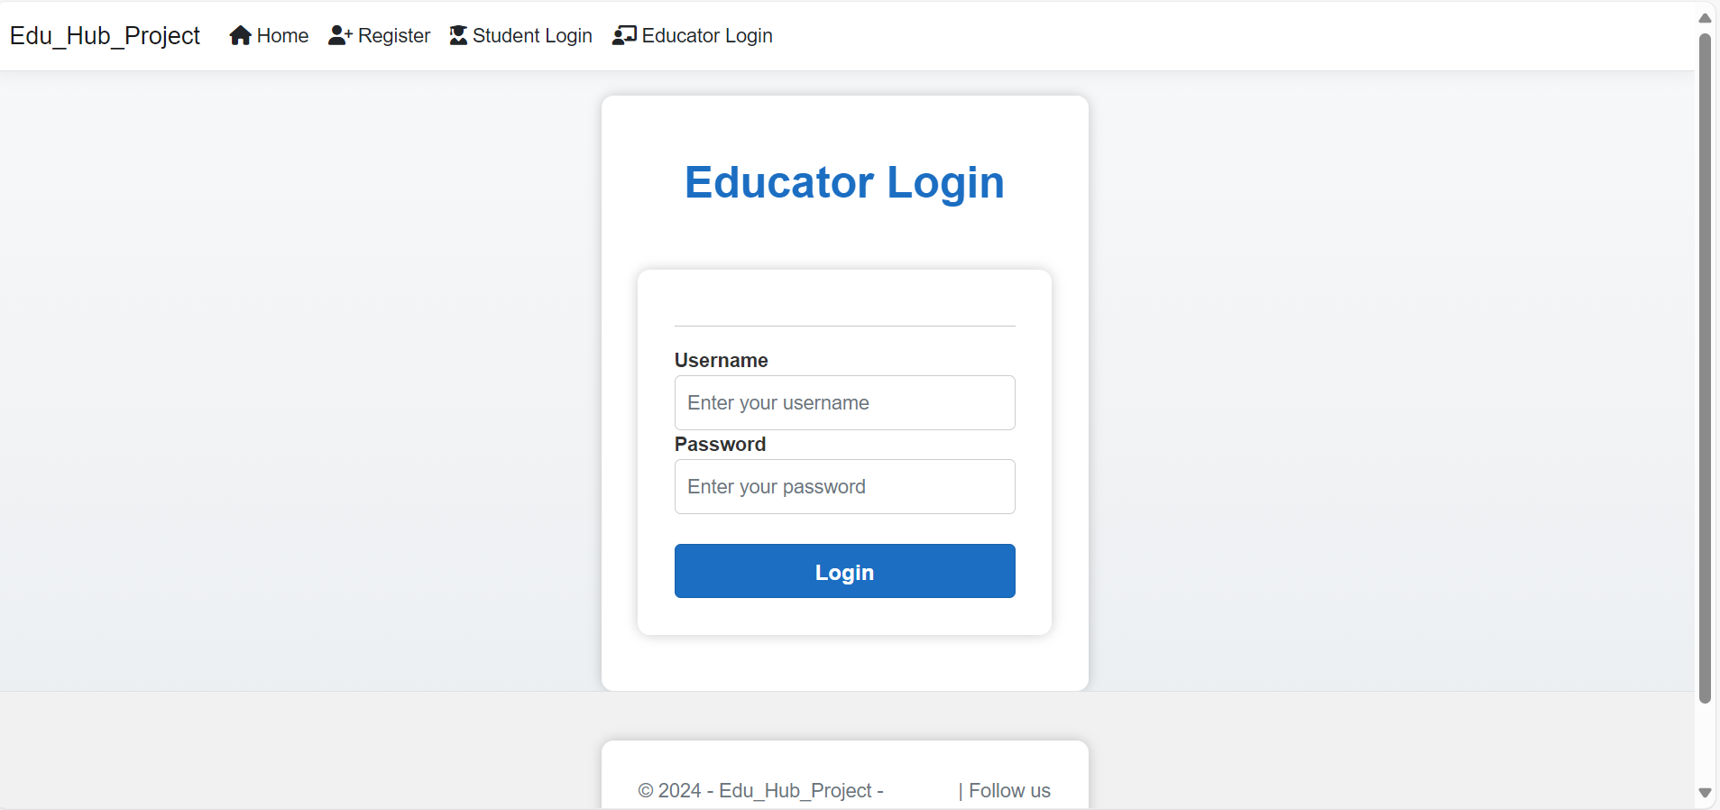**User/ELogin**

1. **User Interface**

* **Login Form Layout:** The login page features a user-friendly interface with fields for entering a username and password, designed to be visually appealing and easy to navigate.
* **Responsive Design:** The page adjusts seamlessly to different screen sizes, ensuring accessibility on various devices (desktops, tablets, smartphones).

**2. Form Components**

* **Input Fields:**
* **Username:** A text input where educators enter their username. It's bound to the Username property of the Login model.
* **Password:** A password input field that masks the entered text for security. It's bound to the Password property of the Login model.
* **Validation Feedback:**
* **Client-Side Validation:** Immediate feedback is provided through validation scripts, ensuring that users are informed of any input errors before form submission.
* **Error Messages**: If validation fails, error messages are displayed next to the relevant input fields, guiding users to correct their entries.

**3. Form Submission Process**

* **Action Method:** The form is configured to submit to an action method called ELogin in the controller when the "Login" button is clicked.
* **HTTP POST Request:** Upon submission, the form data (username and password) is sent as a POST request to the server.

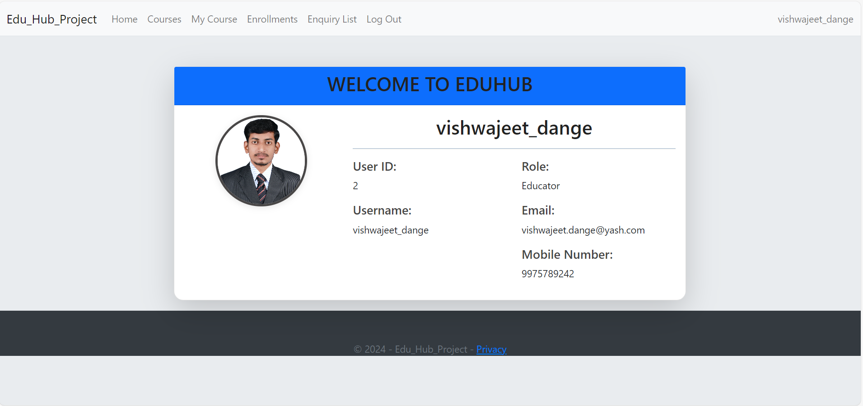**User/EducatorIndex**

**1. User Interface**

* **Dashboard Layout:** The educator index page typically features a well-organized dashboard layout that displays important information and functionalities relevant to educators.
* **Responsive Design:** The page is designed to be accessible on various devices, such as desktops, tablets, and smartphones, ensuring a consistent experience.

**2. Key Components**

* **Navigation Bar:** A navigation menu allows educators to easily access different sections of the application, such as courses, enrollments, enquiry etc.
* **Welcome Message:** A personalized greeting, often including the educator's name, enhances user experience and engagement.

**3. Information Display**

* **Course Overview:** The index page may display a summary of the courses the educator is teaching, including:
* Courses
* My Courses
* Enrollments
* Enquiry List
* **Student List:** A list of students enrolled in the educator’s courses, often with options to view individual student profiles or performance metrics.

**Student Actions:**

**Flow Diagram:**

**Course Management Features for Student**

1. **Enroll in Course:**

* **Browsing Available Courses:** Students can explore a catalog of courses offered by educators, filtering by subject, level, or availability.
* **Enrollment Request:** After selecting a course, students submit an enrollment request. This request is sent to the educator for approval, ensuring that only eligible students can join.

1. **View Course Materials:**

* **Access to Materials:** Once enrolled, students can access various materials uploaded by the educator, such as lecture notes, presentations, videos, and reading materials.
* **Organized Structure:** Course materials are typically organized by week or topic, making it easy for students to navigate and find relevant content.

1. **View Enrolled Courses:**

* **Course List:** Students can view a comprehensive list of all courses they are currently enrolled in.
* **Course Details:** Each course entry includes vital information such as:
* **Course Title:** The name of the course.
* **Description:** A brief overview of the course content and objectives.
* **Start and End Dates:** Important dates that help students manage their schedules.

1. **Submit Enquiries:**

* **Direct Communication:** Students can submit questions or concerns related to course content, assignments, or other topics directly to the educators.
* **User -Friendly Form:** A simple form allows students to describe their enquiry, ensuring they provide sufficient context for the educator to respond effectively.

1. **View Enquiries:**

* **Tracking Submissions:** Students can view a list of all enquiries they have submitted for each course.
* **Status Updates:** Each enquiry includes its status (e.g., pending, answered) and any responses from educators, allowing students to follow up if necessary.

1. **Feedback:**

* **Post Feedback:** Students can provide feedback on courses and educators, sharing their thoughts on the course structure, materials, and overall experience.
* **View Feedback:** Students can also view feedback they have received, which can help them understand areas for improvement and strengths in their learning approach.

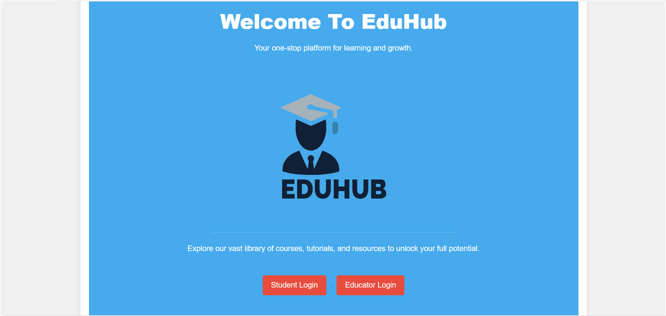

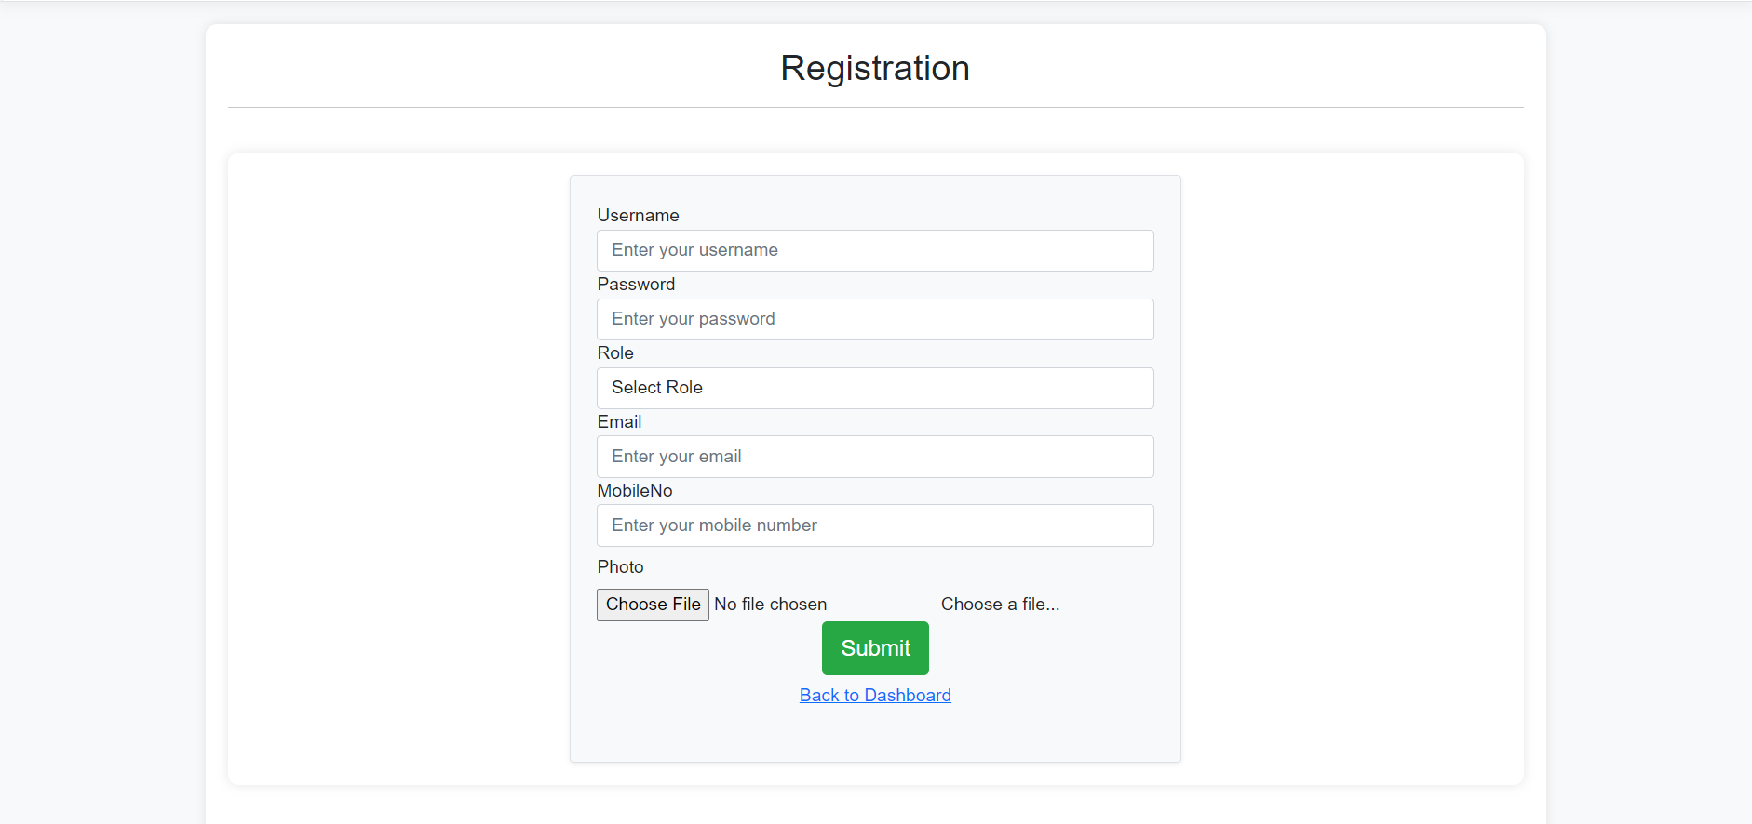

**Student View**

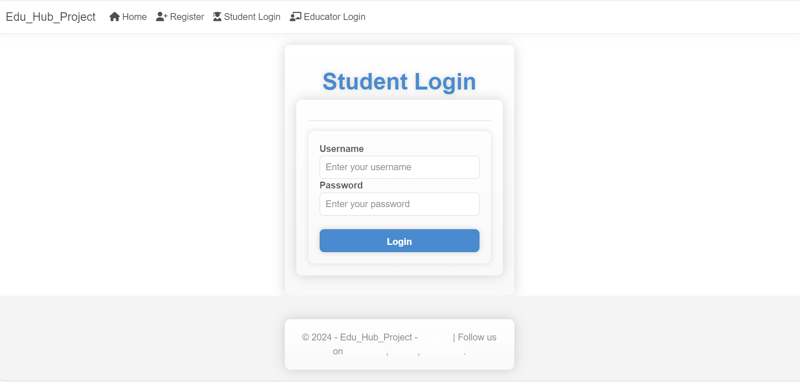**User/SLogin**

1. **User Interface**

* **Simple Layout:** The login page typically features a clean and straightforward design, allowing users to focus on the login process without distractions.
* **Branding:** The institution’s logo and colors are often displayed prominently to create familiarity and trust.

**2. Key Components**

**Login Form:**

* **Username/Email Field:** A field for students to enter their username or email address associated with their account.
* **Password Field:** A secure input field for the password, often masked for privacy.
* **Login Button:** A prominent button to submit the login information and access the student dashboard.

**3. Additional Features**

* **Forgot Password Link:** A link for students who have forgotten their password, directing them to a password recovery process, which typically involves email verification.
* **Sign-Up Link:** For new users, a link to create an account if they do not already have one, guiding
* them through the registration process.

**4. Security Measures**

* **Input Validation:** The system checks the format of the entered username/email and password to

ensure they meet specific criteria before submission.

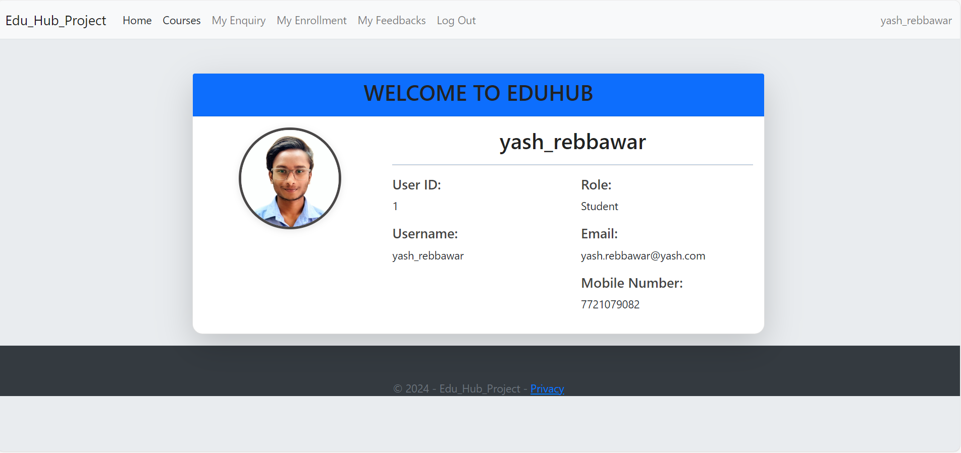**User/StudentIndex**

1. **User Interface**

* **Dashboard Layout:** The index page typically features a well-organized layout, presenting information in a clear and visually appealing manner.

Sections may be divided into cards or panels for easy navigation.

* **Branding:** The institution's logo and color scheme are prominently displayed to reinforce branding and create a familiar environment for students.

**2. Key Components**

* **Welcome Message:** A personalized greeting that may include the student’s name, enhancing user engagement.
* **Navigation Menu:** A sidebar or top navigation bar containing links to various sections, such as:
* Courses
* My Enquiry
* My Enrollments
* My Feedback

**3. Course Overview**

* **List of Enrolled Courses:** A section displaying all courses the student is currently enrolled in, often presented in a tabular or card format.
* Each course entry typically includes:
* **Course Title**: The name of the course.
* **Course Status:** Information on whether the course is ongoing, completed, or upcoming.
* **Start and End Dates:** Key dates for the course.
* **Quick Access Links:** Direct links to access course materials, submit assignments, or participate in discussions for each enrolled course.

**4. Notifications and Alerts**

* **Important Announcements:** A section for displaying recent announcements from educators or the institution, ensuring students stay informed about course updates and deadlines.
* **Alerts for Enquiries and Feedback:** Notifications regarding the status of submitted enquiries and feedback, such as responses from educators or reminders for pending actions.

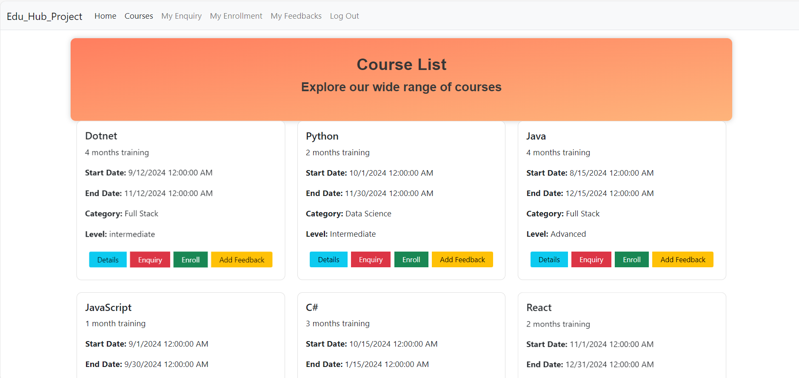

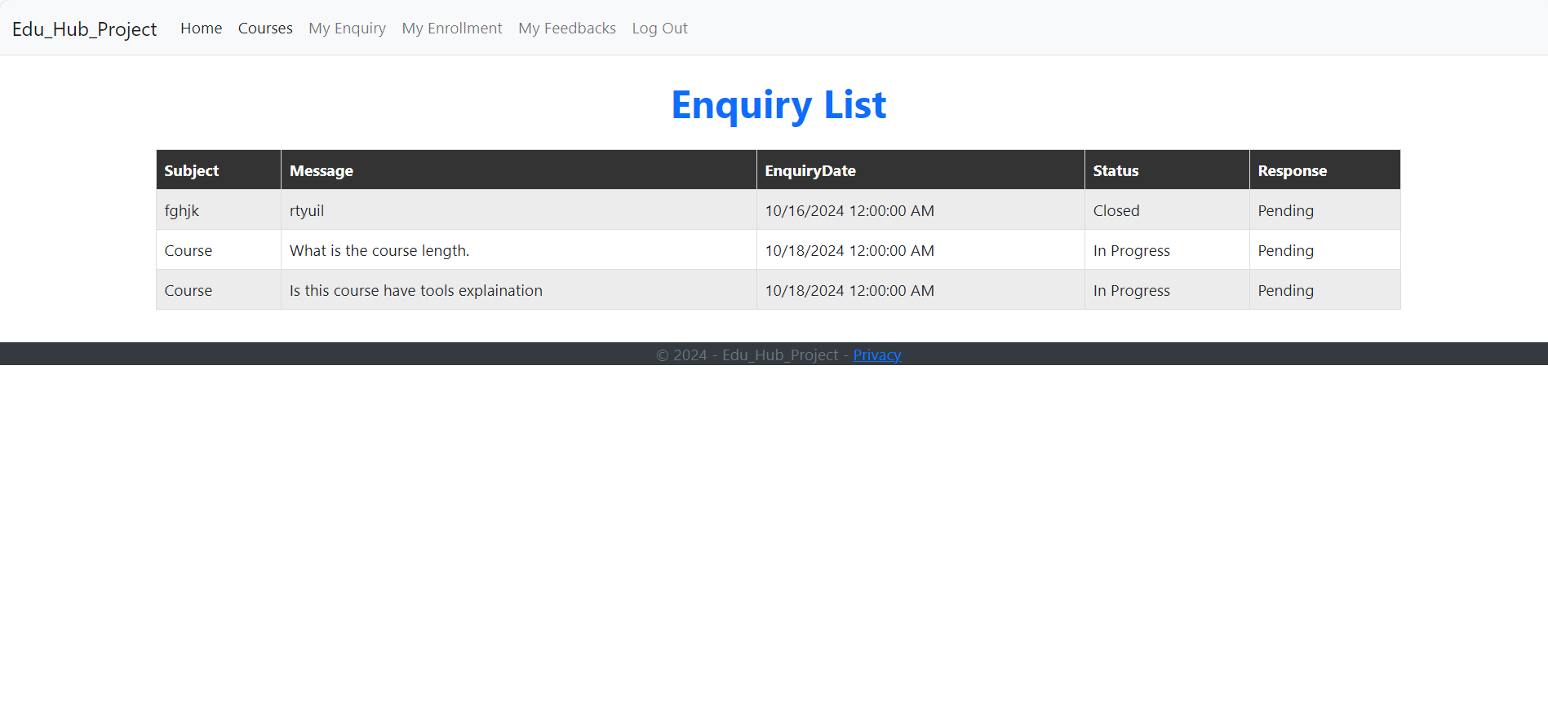

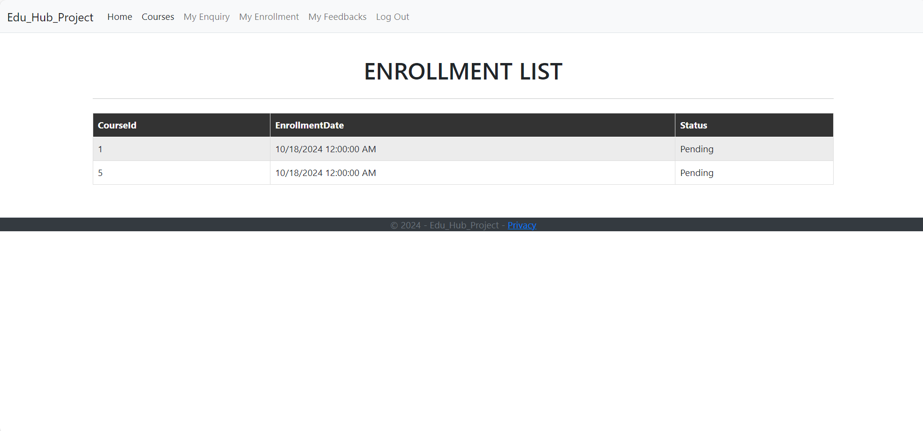

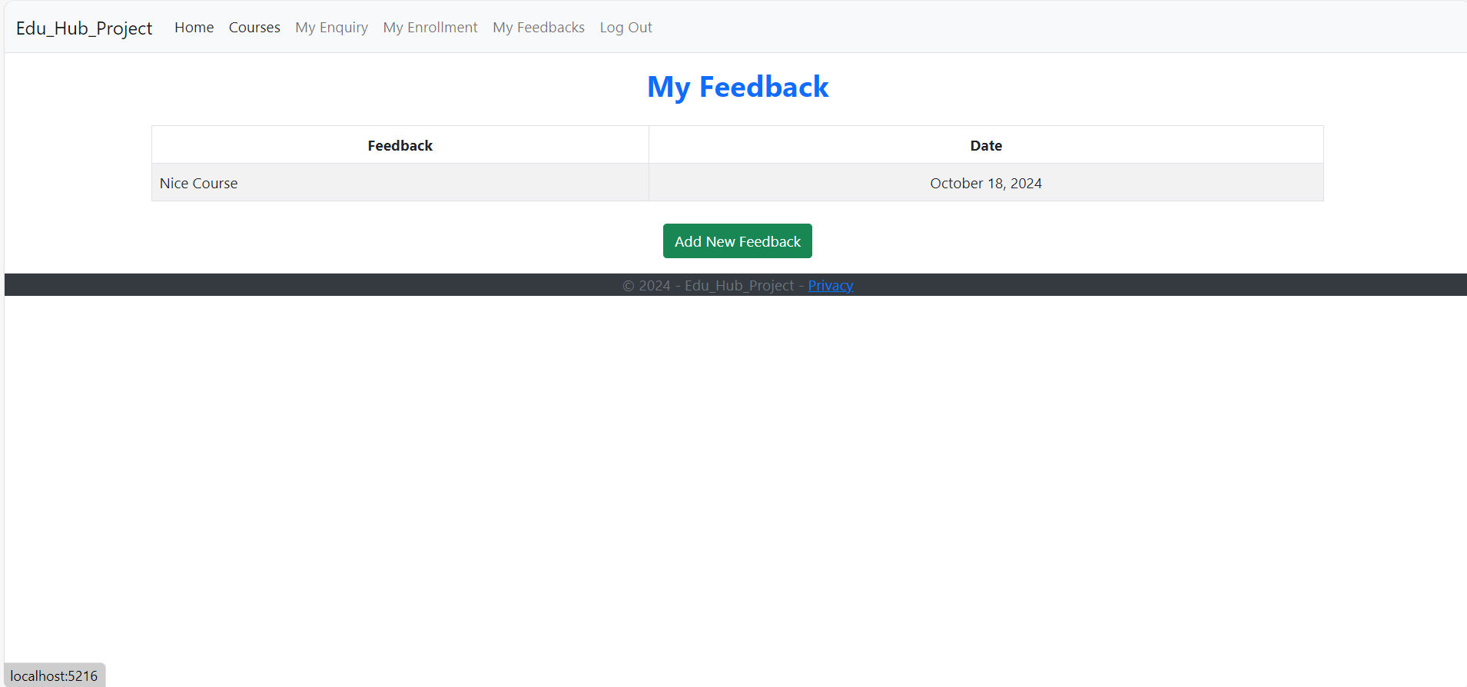

**Conclusion**

EduHub offers a transformative online platform that empowers both educators and students in their educational journey. With comprehensive resources and tools, students can engage in self-paced learning while educators efficiently create and manage courses tailored to student needs.

* **Personalized Learning Experiences:** EduHub fosters academic growth by allowing students to learn at their own pace, accommodating diverse learning styles and preferences. This flexibility enhances student engagement and motivation.
* **Efficient Course Management:** Educators benefit from streamlined tools that simplify course creation, material distribution, and student communication. This efficiency allows them to focus more on teaching and less on administrative tasks.
* **Enhanced Collaboration:** The platform promotes interaction between students and educators through features like enquiries and feedback, creating a supportive learning environment where students feel valued and heard.
* **Revolutionizing Education:** By combining innovative technology with educational best practices, EduHub is reshaping the landscape of education, making learning more accessible and effective for all participants.